EE5351 DIGITAL VIDEO CODING

ASSIGNMENT 4

SCALAR QUANTIZATION

NAME:PAVAI ARCHIMEDES

ST ID:1001233996

1), The pixel values in the Sena image are not really distributed uniformly. Obtain a histogram of the image.

PROGRAM:

clc;

close all;

clear all;

figg= fopen('sena.img');

Image=fread(figg);

Image=reshape(Image,256,256);

[count,x]=imhist(uint8(Image'));

sum=sum(count);

p=count/sum;

plot(x,p);

title('hist'); xlabel('x');

ylabel('h');

figure;

imshow(uint8(Image'));

title('sena img');

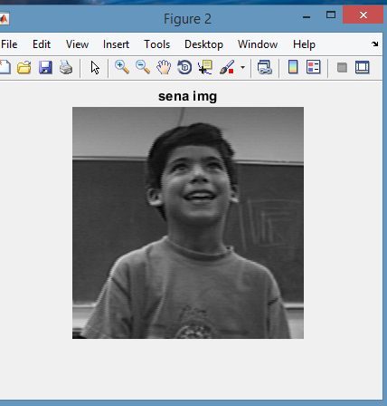

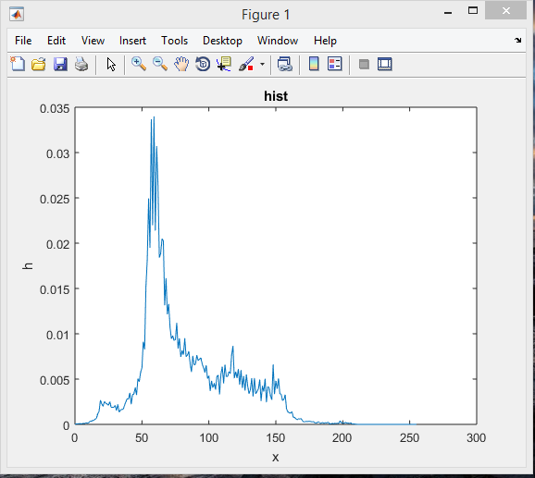

FROM THE GRAPH WE CAN CONCLUDE THAT IT’S AN LAPLACIAN TRANSFORM.

2), Applying 1-,2-,3-bit uniform quantizer to the Sena image. Compute the mse of the uniformed quantized image and show the quantized image.

PROGRAM:

clc;

clear all;

close all;

fid = fopen('sena.img');

img = fread(fid,[256,256]);

img = img';

subplot(2,2,1);

imshow(uint8(img));

title('sena img');

for i= 1:256

for j= 1:256

if (img(i,j)>= 0 && img(i,j)< 128)

q_sena1(i,j) = 64;

elseif (img(i,j)>= 128 && img(i,j)< 256)

q_sena1(i,j) = 192;

end end

end

subplot(2,2,3) ;

imshow(q_sena1,[]);

title('1-bit qu sena img');

msebit1 = sum(sum((img - q_sena1).^2))/(256*256);

msebit1

for i= 1:256

for j= 1:256

if (img(i,j)>= 0 && img(i,j)< 64)

q_sena2(i,j) = 32;

elseif (img(i,j)>= 64 && img(i,j)< 128)

q_sena2(i,j) = 96;

elseif (img(i,j)>= 128 && img(i,j)< 192)

q_sena2(i,j) = 160;

elseif (img(i,j)>= 192 && img(i,j)< 256)

q_sena2(i,j) = 224;

end

end

end

subplot(2,2,3);

imshow(q_sena2,[]);

title('2-bit qu sena img');

msebit2

= sum(sum((img - q_sena2).^2))/(256*256)

msebit2

for i= 1:256

for j= 1:256

if (img(i,j)>= 0 && img(i,j)< 32)

q_sena3(i,j) = 16;

elseif (img(i,j)>= 32 && img(i,j)< 64)

q_sena3(i,j) = 48;

elseif (img(i,j)>= 64 && img(i,j)< 96)

q_sena3(i,j) = 80;

elseif (img(i,j)>= 96 && img(i,j)< 128)

q_sena3(i,j) = 112;

elseif (img(i,j)>= 128 && img(i,j)< 160)

q_sena3(i,j) = 144;

elseif (img(i,j)>= 160 && img(i,j)< 192)

q_sena3(i,j) = 176;

elseif (img(i,j)>= 192 && img(i,j)< 224)

q_sena3(i,j) = 208;

elseif (img(i,j)>= 224 && img(i,j)< 256)

q_sena3(i,j) = 240;

end

end

end

subplot(2,2,4);

imshow(q_sena3,[]);

title('3-bit qu sena img');

msebit3 = sum(sum((img - q_sena3).^2))/(256*256);

msebit3

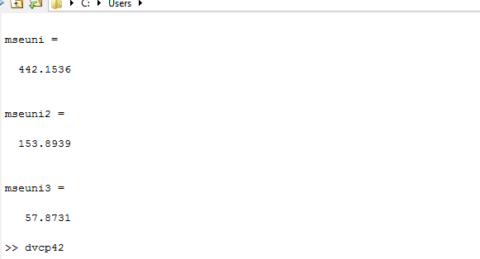

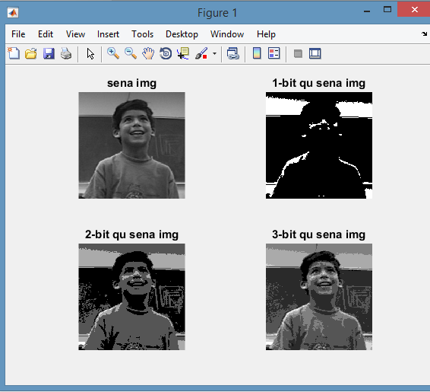

3), Design 1-,2-,3-bit quantizer for the Sena image, which can match the distribution  better than a simple uniform quantizer. Compute the mse of the quantized image and show the quantized image.

PROGRAM:

clc;

close all;

clear all;

fid= fopen('sena.img');

image= fread(fid,[256,256]);

image = image';

image = uint8(image);

[cnt,x] = imhist(image);

h=cnt/s;

s=sum(cnt);

subplot(2,2,1);

imshow(uint8(image));

title('sena img');

P = [1/16:1/16:15/16];

i = 0;

j = 1;

for k = 1:15

while i < P(k)

i = i + h(j);

j = j + 1;

end

cdf(k) = j;

end

image = double(image);

for i= 1:256

for j= 1:256

if image(i,j)< cdf(8)

q_sena1(i,j) = cdf(4);

else

q_sena1(i,j) = cdf(12);

end

end

end ows

subplot(2,2,2);

imshow(q_sena1,[]);

title('1-bit qu sena img');

mseuni = sum(sum((image - q_sena1).^2))/(256*256);

mseuni

for i= 1:256

for j= 1:256

if image(i,j)< cdf(4)

q_sena2(i,j) = cdf(2);

elseif image(i,j)>= cdf(4) && image(i,j)< cdf(8)

q_sena2(i,j) = cdf(6);

elseif image(i,j)>= cdf(8) && image(i,j)< cdf(12)

q_sena2(i,j) = cdf(10);

elseif image(i,j)>= cdf(12)

q_sena2(i,j) = cdf(14);

end

end

end

subplot(2,2,3);

imshow(q_sena2,[]);

title('2-bit qu sena img');

mseuni2= sum(sum((image - q_sena2).^2))/(256*256);

mseuni2

for i= 1:256

for j= 1:256

if image(i,j)< cdf(2)

q_sena3(i,j) = cdf(1);

elseif image(i,j)>= cdf(2) && image(i,j)< cdf(4)

q_sena3(i,j) = cdf(3);

elseif image(i,j)>= cdf(4) && image(i,j)< cdf(6)

q_sena3(i,j) = cdf(5);

elseif image(i,j)>= cdf(6) && image(i,j)< cdf(8)

q_sena3(i,j) = cdf(7);

elseif image(i,j)>= cdf(8) && image(i,j)< cdf(10)

q_sena3(i,j) = cdf(9);

elseif image(i,j)>= cdf(10) && image(i,j)< cdf(12)

q_sena3(i,j) = cdf(11);

elseif image(i,j)>= cdf(12) && image(i,j)< cdf(14)

q_sena3(i,j) = cdf(13);

elseif image(i,j)>= cdf(14)

q_sena3(i,j) = cdf(15);

end

end

end

subplot(2,2,4);

imshow(q_sena3,[]);

title('3 bit qu sena img');

mseuni3= sum(sum((image - q_sena3).^2))/(256*256);

mseuni3

